How To Grant Access To Only One S3 Bucket Using AWS IAM Policy

https://docs.aws.amazon.com/AmazonS3/latest/dev/example-walkthroughs-managing-access-example1.html

Step 1:
Login to the IAM AWS console,Login as the owner of the AWS account. Click the IAM tab.

Step2: Create a new group or a new user, Set a password for the new use
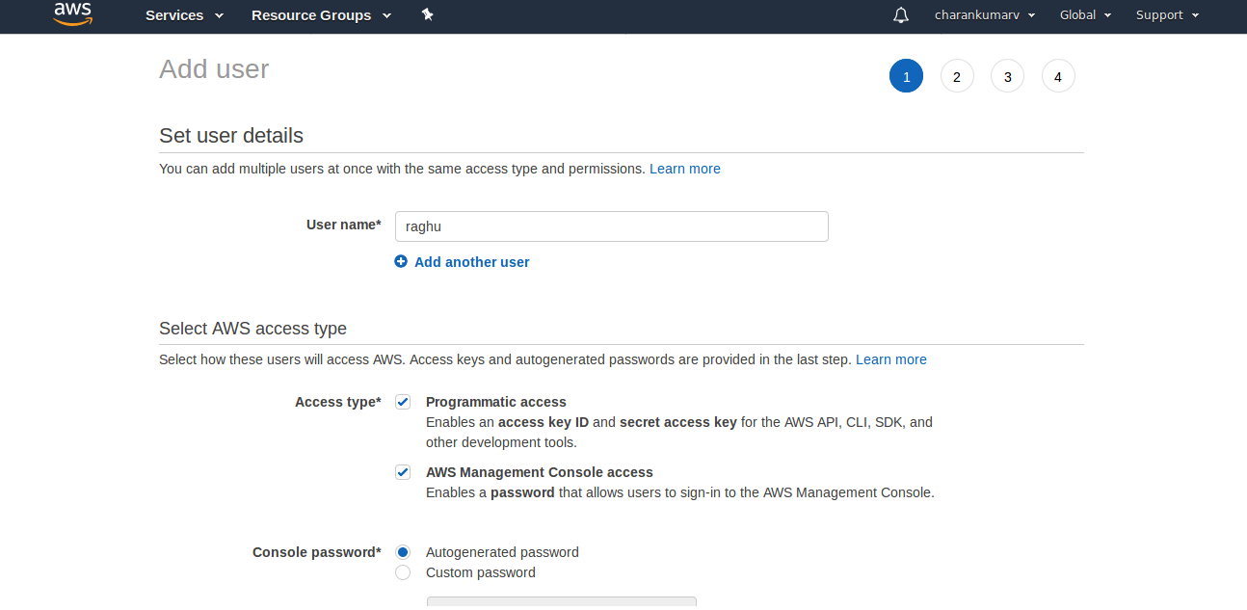
Note down the raghu credentials.
Note down the Amazon Resource Name (ARN) for raghu In the IAM console, select the user, and the Summary tab provides the user ARN.
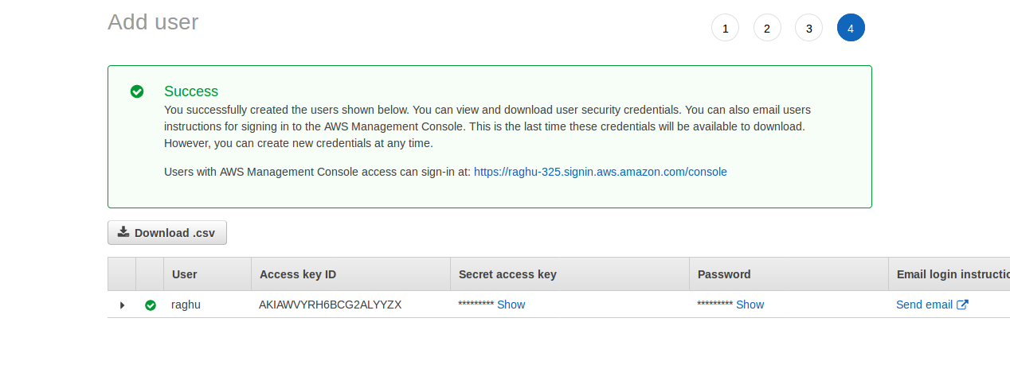

Step3: Add permissions for your user
Permissions are added either on the group the user is in, or if you decided not to create a group, the user account itself.
Click the user or group, then click the Permissions tab. Here you can see which permissions policies are currently attached to the group or user. Click the Attach Policy button. You’ll get a pop-up where you can Manage User Permissions. Here you can select a prerolled policy, use the Policy Generator, or just paste in a custom policy.
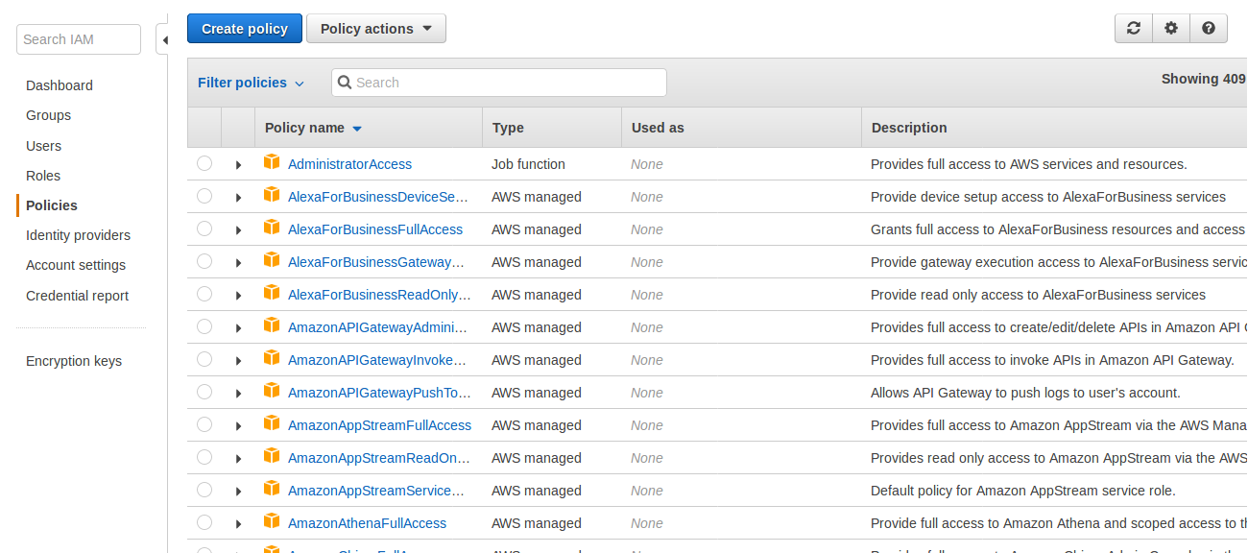

Click on Create Policy:

Please refer this guide have any quries:
Link: https://docs.aws.amazon.com/IAM/latest/UserGuide/id_users_create.html#id_users_create_console

Fill out the “Policy Name”, “Description” and “Policy Document” fields.
Replace “YOUR-BUCKET” in the example below with your bucket name.
Note: The "s3:ListAllMyBuckets" is used to list all buckets owned by you, so that tools that list buckets will work.
The "s3:GetBucketLocation" is needed so that ObjectiveFS can select the right S3

Mention Bucket name which bucket want to user restrict.:

{
"Statement": [
{
"Effect": "Allow",
"Action": "s3:ListAllMyBuckets",
"Resource": "arn:aws:s3:::*"
},
{
"Effect": "Allow",
"Action": "s3:*",
"Resource": [
"arn:aws:s3:::test_bucket0011",
"arn:aws:s3:::test_bucket0011/*"
]
}
]
}

Step4:
Create Custom Policy--->Json---> Paste above json format--> review Policy-->save Policy

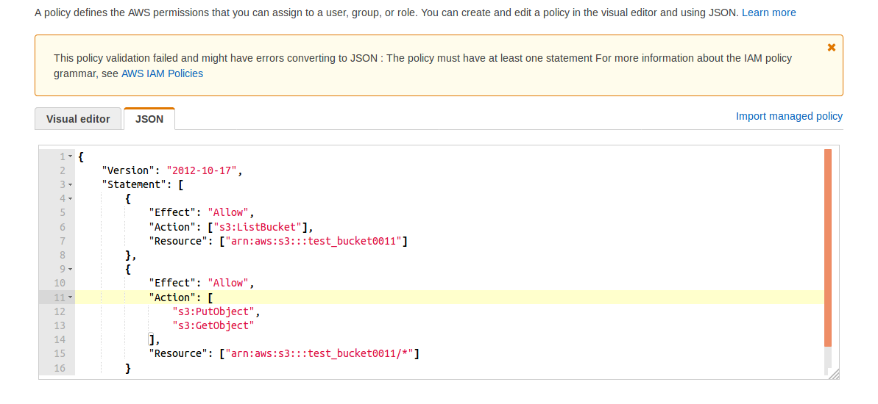

Create Resources (a Bucket ) in Account and Grant Permissions:

Step5:

Click on policy---> Policy action--->Attach---username

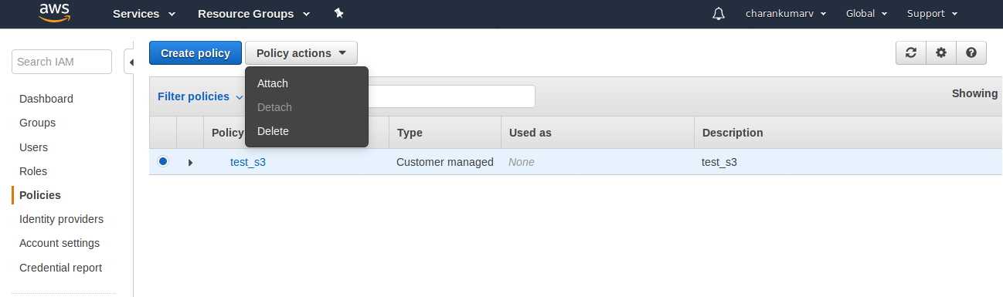

Step6:
Select username----> AttachPolicy

